Soprano and Academician
Cav. Dr. Ang Mei Foong
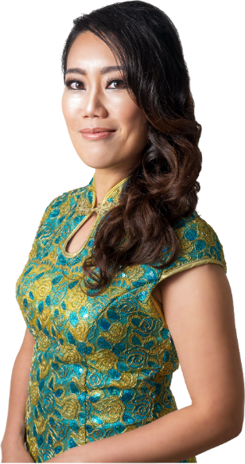
Youtube: https://www.youtube.com/c/MeiFoongAng
Spotify: Ang Mei Foong
Artistic Website: www.angmeifoong.com
Mei Foong’s voice was described as mellow, dulcet and soothing to the listeners. A multiple awards and scholarships winner, she was trained at the National Taiwan Normal University under Prof. Ren Rong, Conservatorio di Musica Santa Cecilia under Maestro Rebecca Berg, and the University of Melbourne under Merlyn Quaife. She now holds a PhD from University Putra Malaysia.
An award-winning soprano, she was a recipient of numerous academic scholarships during her study notably the "Melbourne International Fee Remission Scholarships" (MIFRS) and "Melbourne International Research Scholarships" (MIRS) when she pursued her studies in the University of Melbourne. Other notable awards include the first prize winner of NTNU Vocal Concerto Competition of year 2002; 2nd prize winner of the Taiwan Rotary Club Artists' Awards of year 2002; the 8th prize winner, as well as a young artist award of "Mondial Chinese Vocalists Concours 2003"; and "Silver Medal Winner Award- Outstanding Achievement" in the Global Music Award, Oct 2014; In 2018, she was bestowed with “Ordine della Stella D'Italia, l'onorificenza Cavaliere” (The Order of Star of Italy, with the conferment of Knighthood), a prestigious recognition by the Italian government of her outstanding contribution to programming and performing vocal arts in the regions; followed with the Golden Medal Award from the Berliner International Music Competition in Sep 2018; the Best Solo Performance (Vocal) award in the 16th Boh Cameron Arts Awards 2019, one of the most prestigious performing arts awards in Malaysia; and most recently she received the National Academics Awards (category of Performing Arts) by Ministry of Education Malaysia in which the award was presented by the Prime Minister Malaysia, Tun Dr. Mahathir, on 29 Oct 2019.
​
As an active recitalist, Mei Foong has given several well received solo recitals in Kuala Lumpur, Taiwan, Macau, Rome and Melbourne, where she performed Robert Schumann’s Frauenliebe und Leben, Gabriel Faure’s La Bonne Chanson, Richard Strauss’s Vier letzte Lieder, Aldo Finzi’s Art Songs, Alban Berg’s Sieben frühe Lieder, Joseph Canteloube’s Chants d’auvergne, and appeared as the soprano soloist in Handel's Ode for St. Cecilia's Day, Handel's Messiah, and Beethoven's Symphony No. 9. She is the founder and artistic director of The Song Weavers, the Malaysian first vocal ensemble that is dedicated to the performance and programming of Art Songs.

She has collaborated with a few major orchestras and ensembles in Malaysia, which include both the Malaysian Philharmonic Orchestra (MPO), and the Malaysian Philharmonic Youth Orchestra (MPYO), Kamerata String Ensemble and the Virama Ensemble. She has worked with the conductors such as Lee Kok Leong, David Chin, Bernard Tan, Juan Montoya, Kevin Field, Ciarán McAuley, Fabio Mechetti, Sergio La Stella, Guillaume Tourniaire, Naohisa Furusawa, and Alessandro Mazzocchetti.
In 2013, Mei Foong made her Malaysia opera debut playing the title role in Bizet's opera Carmen with the EST opera company (now known as KL City Opera, KLCO), which had been received warmly at Kuala Lumpur, Malaysia. Her other theatrical performances included “the mother” in Menotti’s Amahl and the Night Visitors with KLCO in 2014, and both the roles “Carmen” and “Mercedes” in Bizet’s Carmen with MPO in 2015; In 2016, she performed with KLCO as Mimì in Puccini’s La bohème with KLCO in Aug 2016; The First Lady in Mozart's Die Zauberflöte with MPO in Jan 2017, and the Contessa in Mozart’s Le Nozze di Figaro with KLCO 2017, Violetta Valéry in Verdi's La Traviata with KLCO 2019; and most recently Liù in Puccini’s Turandot with KLCO in Oct 2026 and Floria Tosca in Puccini’s Tosca in Dec 2026.
Mei Foong's love to contemporary music always led her to work closely with the contemporary composers. She actively involved in the Malaysian contemporary music industry and had given world première to the vocal works by the Malaysian composers along with many internationally acclaimed musicians and orchestra, including MPO and the Society of Malaysian Contemporary Composers (SMCC). She has had vocal works composed specifically for her and dedicated to her.
While enjoying her busy performance career, she is also an active researcher in the field of voice rehabilitation, specifically for patients with chronic diseases. Her present research work looks into the effects of singing on people with Parkinson’s Disease. She was also a columnist in the local Chinese press, Sin Chew Daily.
----------------------------------------------------------------------------------------------------------
Ang Mei Foong's album Multicolour Voices is published in 2019!
Ang Mei Foong was awarded the National Academics Awards (category of Performing Arts) by Ministry of Education Malaysia in which the award was presented by the Prime Minister Malaysia, Tun Dr. Mahathir, on 29 Oct 2019.
​
Ang Mei Foong has won Best Solo Performance (solo) under the music category in the 16th Boh Cameronian Arts Award, the most prestigious performing arts awards in Malaysia. 30 Apr 2019
​​Ang Mei Foong has won Golden Medal at the 2018 and 2019 Berliner International Music Competition.
​Ang Mei Foong is bestowed as Knight, the Order of the Star of Italy on the 29 Jan 2018.
----------------------------------------------------------------------------------------------------------
REVIEWS
"It is a rare opportunity to be able to work so creatively and seamlessly with an actor/ opera singer in the way I have had the pleasure of working with Mei Foong over these last few weeks. I can boldly say that I have enjoyed every minute of the process."

Christopher Ling
Director of "Amahl and the Night Visitors", 2014

"Ang Mei Foong's voice is simply powerful, incredible and mind blowing. Everyone was mesmerized by her voice... She is a true inspiration."
Alice Lee Myles
"Amahl and the Night Visitors", 2014

"Ang Mei Foong, a Lirico soprano, delivered euphonious melodies with lovely poignant qualities which were mellow, dulcet and soothing to the listener. Her rendition of "Tacea la notte" from Verdi's "Il Trovatore" was well controlled and even though sung in Italian immediately conveyed the mood of the aria through her heartfelt interpretation."
Phillip Chai
"Stelle", May 2016

"​KLCO's production of La bohème tonight 27 August 2016 featuring Mei Foong Ang as Mimi was a showcase for Mei Foong's beautiful lyrico soprano voice. Her "Mi chiamano Mimi“ was dramatic and made an electrifying impact. Her voice was silky and had a beautiful timbre in most parts of the performance. Not only that, her performance established firmly that Mei Foong is not just a singer but an opera performer as well. Bravissimo for a superb performance!!"
​Phillip Chai
"La bohème", Oct 2016
"It was the consensus of the commission that your performances reflect musicality, depth of interpretation, and technical expertise needed to distinguish oneself in the world of professional performance."
Berliner International Music Competition Commission
​1 Sep 2018

"Her (Ang Mei Foong) leading role as Violetta showcased her stunning vocal dexterity and quality that was breath-taking even for us who have watched almost all her previous performances."

Dr. Kua Kia Soong,
KLCO production of "La Traviata", June 2019

“Ang Mei Foong’s voice is a gift indeed ~ an instrument of beauty, power, and soul. Listening to her sing is like being enveloped in honey, cream, and liquid gold. Her tone is smooth yet rich, warm yet vibrant, flowing effortlessly through each note with a kind of elegance that defies gravity. Her voice opens up like a flower in full bloom, delicate at first, then expanding with grace and majesty. In performance, it soars—lifting and gliding through the air as if it belongs to the heavens. Her high notes feel like gentle raindrops falling on still water, sending ripples of emotion through the hearts of her listeners. There is something timeless in the way she sings. Mei Foong doesn't merely perform; she teaches, she reveals. Her voice carries the weight of experience, the wisdom of an old teacher with a profound message. It reaches into the deepest parts of your soul, awakening something forgotten, something true.
Whether interpreting a soaring aria or the quietest of lullabies, Mei Foong's voice is a living, breathing presence—one that lingers long after the final note has faded...”

Alicia Tan
Ang Mei Foong’s Solo Concert with Kuala Lumpur Performing Arts Orchestra
18 May 2025

Creative Outputs
Music Publications (Discography/ Video and Music Recordings)
 | Items | Year
1. | Ang Mei Foong Solo Recital (Master of Music 1) | 2006
2. | Ang Mei Foong Solo Recital (Master of Music 2) | 2007
3. | Venerable Seck Guo Neng Commemoration CD | 2011
4. | Hark! The Songs of Homeland, WORLD PREMIERE collection of Malaysian Newly composed Art Songs | 2012
5. | Opera in Four Acts: Carmen (KLCO) | 2013
6. | Ang Mei Foong Solo Recital: Women’s Love and Life 1 | 2014
7. | Ang Mei Foong Solo Recital: Women’s Love and Life 2 | 2014
8. | Bravissimo | 2014
9. | Carmen for the Family (MPO) | 2015
10. | Opera in Four Acts: Carmen (MPO) | 2015
11. | Encore | 2015
12. | If Music Be the Food of Love, WORLD PREMIERE of Malaysian Art Songs, The Song Weavers, DPAC Arts Festival | 2016
13. | Opera in Four Acts: La bohème (KLCO) | 2016
14. | Magic in Music (MPO) | 2017
15. | Opera in Four Acts: The Magic Flute (MPO) | 2017
16. | Multicolor Voices (CD of Malaysian Art Songs) | 2019
Music Recording- Sound Recording (Intellectual Property: Copyrighted)
 | Items | Year
1. | MF Ang, Cermin Edina (Mirror Edina) SR2020007217 |  | 2020
2. | MF Ang, Clair de Luna (Moonlight) SR2020007214 |  | 2020
3. | MF Ang, Echo Sound Record, SR2020007211 |  | 2020
4. | MF Ang, Gagak Parit (The Crow) SR2020007215 |  | 2020
5. | MF Ang, Menambat Rakit (Towing a Raft) SR2020007213 |  | 2020
6. | MF Ang, Mimpi dalam Lagu (Dreams in Songs) SR2020007216 |  | 2020
7. | MF Ang, Nona, SR2020007209 |  | 2020
8. | MF Ang, O! Never Say that I was False of Heart, SR2020007210 |  | 2020
9. | MF Ang, When We Two Parted, SR2020007212 |  | 2020
10. | MF Ang, 你是人間的四月天 (You are the April in this World), SR2020007233 |  | 2020
11. | MF Ang, 像一隻小鳥 (Like a Bird) SR2020007218 |  | 2020
12. | MF Ang, 再戀 (To Love Again) SR2020007221 |  | 2020
13. | MF Ang, 圓月中秋 (Autumn) SR2020007230 |  | 2020
14. | MF Ang, 彤雲天邊飛 (Colourful Clouds in the Sky) SR2020007221 |  | 2020
15. | MF Ang, 悟 (Realization) SR2020007225 |  | 2020
16. | MF Ang, 情緣 (Love Fate) SR2020007282 |  | 2020
17. | MF Ang, 我等候你 (Longing for You) SR2020007231 |  | 2020
18. | MF Ang, 星遇 (Meeting a Star) SR2020007220 |  | 2020
19. | MF Ang, 聽彈琴 (Listen to Qin) SR2020007228 | 2020
20. | MF Ang, 花蹤之歌 (Song of Flowers) SR2020007232 | 2020
21. | MF Ang, 茨廠街 (Petaling Street) SR2020007219 | 2020
22. | MF Ang, 迴夢曲 (In a Dream) SR2020007229 | 2020
23. | MF Ang, 這一天 (This Day) SR2020007224 | 2020
24. | MF Ang, 這一條路 (This Road) SR2020007223 | 2020
25. | MF Ang, 鄉村來的消息 (Message from the Kampung) SR2020007226 | 2020
26. | MF Ang, 黃花 (Yellow Flower) SR2020007222 | 2020
27. | MF Ang, Come Together (Music Recording) (SR2022W05069) | 2022
28. | MF Ang, Come Together (Music Score) (MC2022W04753) | 2022
29. | MF Ang, A Blossomed Tree (MC2024W01782) | 2024
30. | MF Ang, In the Deep Night (MC2024W01783) | 2024
31. | MF Ang, With You I Never Alone (SR2024W07423) | 2024
32. | MF Ang, With You I Never Alone (accompaniment) (MC2024W07422) | 2024
33. | MF Ang, Choose Joy Choose Peace SR2025W01905 | 2025
34. | MF Ang, Choose Joy Choose Peace (accompaniment) MC2025W01905 | 2025
35. | MF Ang, Greeting Song in C (status-applied) | 2025
36. | MF Ang, Greeting Song in C (accompaniment) (status-applied) | 2025
37. | MF Ang, Greeting Song in D (status-applied) | 2025
38. | MF Ang, Greeting Song in D (accompaniment) (status-applied) | 2025
39. | MF Ang, Greeting Song in E (status-applied) | 2025
40. | MF Ang, Greeting Song in E (accompaniment) (status-applied) | 2025
41. | MF Ang, Greeting Song in F (status-applied) | 2025
42. | MF Ang, Greeting Song in F (accompaniment) (status-applied) | 2025
43. | MF Ang, The Joy of Talking SR2025W01906 | 2025
44. | MF Ang, The Joy of Talking (accompaniment) MC2025W00560 | 2025
45. | MF Ang, Warm-Up and Stomp SR2025W03682 | 2025
46. | MF Ang, Warm-Up and Stomp (accompaniment) MC2025W03678 | 2025
47. | MF Ang, Rasa Sayang (status-applied) | 2025
48. | MF Ang, Rasa Sayang (accompaniment) (status-applied) | 2025
49. | MF Ang, Getaran Jiwa (status-applied) | 2025
50. | MF Ang, Getaran Jiwa (accompaniment) (status-applied) | 2025
51. | MF Ang, Somewhere Over the Rainbow (status-applied) | 2025
52. | MF Ang, Somewhere Over the Rainbow (accompaniment) (status-applied) | 2025
53. | MF Ang, What a Wonderful World (status-applied) | 2025
54. | MF Ang, What a Wonderful World (accompaniment) (status-applied) | 2025
55. | MF Ang, 甜蜜蜜 Tian Mi Mi (status-applied) | 2025
56. | MF Ang, 甜蜜蜜 Tian Mi Mi (accompaniment) (status-applied) | 2025
57. | MF Ang, 月亮代表我的心 The Moon Represents My Heart (status-applied) | 2025
58. | MF Ang, 月亮代表我的心 The Moon Represents My Heart (accompaniment) (status-applied) | 2025
Creative Outputs (Music Performances)
Opera
 | Details | Date
1. | Bizet: Carmen/ as Carmen/ with Florian Caroubi (Cond.) EST Opera/ Black Box @ MAP Publika, Kuala Lumpur | 29, 31 Oct –  1, 3 Nov 2013
2. | Menotti: Amahl and the Night Visitors/ as The Mother/ EST Opera/ Black Box @ MAP Publika, Kuala Lumpur | 6-7 Dec 2014
3. | Prince Siddhartha The Musical/ as the lead prologue singer & Princess Yashodhara/ Asia Musical Productions (AMP)/ Manhattan Ballroom, Times Square, Kuala Lumpur | 31 Dec 2014 –  1 Jan 2015
4. | Bizet: Carmen/ as Carmen/ with Mick Doran (Presenter) and Ciarán McAuley (Cond.)/ Malaysian Philharmonic Orchestra (MPO) Family Series/ Dewan Filharmonik Petronas(DFP), Kuala Lumpur | 24-25 Jan 2015
5. | Bizet: Carmen/ as Mercedes/ Fabio Mechetti (Cond.)/ Malaysian Philharmonic Orchestra (MPO)/ Dewan Filharmonik Petronas(DFP), Kuala Lumpur | 28, 30 Jan –  Feb 1 2015
6. | Puccini: La bohème/ as Mimì/ Juan Montoya (Cond.)/ Kuala Lumpur City Opera/ Kuala Lumpur Performing Arts Center (KLPAC)/ Kuala Lumpur | 25, 27 Aug 2016
7. | Mozart: The Magic Flute/ as The First Lady/ Guillaume Tourniaire (Cond.)/ Malaysian Philharmonic Orchestra (MPO)/ Dewan Filharmonik Petronas(DFP), Kuala Lumpur | 14, 15, 17 Jan 2017
8. | Mozart: Le Nozze di Figaro/ as Contessa Almaviva/ Juan Montoya(Cond.)/ Kuala Lumpur City Opera (KLCO)/ Kuala Lumpur Performing Arts Center (KLPAC)/ Kuala Lumpur | 12, 14, 15 Oct 2017
9. | Verdi: La Traviata/ as Violetta/ Juan Montoya(Cond.)/ Kuala Lumpur City Opera (KLCO)/ Kuala Lumpur Performing Arts Center (KLPAC)/ Kuala Lumpur | 27- 30 June 2019
10. | Wang Liping: Dream of the Red Chamber (Theater Version)/ as multiple female roles include Lin Daiyu/ Leong Han Kuei (Cond.)/ Lee Rubber Chinese Orchestra/ Petaling Jaya Performing Arts Center (PJPAC)/ Kuala Lumpur | 6-7 Aug  2022
11. | Puccini: La bohème/ as Mimì/ Cond. tbc/ Kuala Lumpur City Opera/ Kuala Lumpur Performing Arts Center (KLPAC)/ Kuala Lumpur | 4, 5, 6 Oct 2024
Concerts
 | Details | Date
1. | Liebesbotschaft- Love Message/ Soloist/ Artists Platform/ German Ambassador's Residence, Kuala Lumpur | 5 Jan 2010
2. | MPO Composer Forumplus/ Soloist (*World Premièred to Wong Chee Yean's "Triptych")/ Malaysian Philharmonic Ochestra (MPO)/ Kevin Field (Cond.)/ Dewan Filharmonik Petronas (DFP), Kuala Lumpur | 20 Feb 2010
3. | Tan Hooi Song Memorial Concert/ Soloist (*World Première "悟" by the late Tan Hooi Song)/ Johor Bharu | 31 Jul 2010
4. | Boundless Aspiration (Dharma Concert)/ Soloist/ Hong Kong Buddhist Centre/ Hong Kong | 11 Oct 2010
5. | Schumannfest (Robert Schumann 200th Anniversary“ of Foreign Lands and People”/ Soloist/ Artists Platform/ KLSCAH, Kuala Lumpur | 31 Oct 2010
6. | KL Music Festival/ as Empress Yang Kwei Fei/ Cantata: Song of unending sorrow/ Soloist/ KL Music Festival Committee/ Chin Woon Stadium, Kuala Lumpur | 20 Nov 2010
7. | A Viennese Afternoon featuring Alban Berg’s Sieben frühe Lieder/ Soloist/ Wong Chee Yean (Pianist)/ Annex Gallery, Kuala Lumpur | 1 May 2011
8. | Musical Rendezvous 11 (MIA)/ Guest Performer (World Premièred " Meeting a Star" by Malaysian Composer MR. Yeo Chow Shern/ KLSCAH, Kuala Lumpur | 8 May 2011
9. | Sentimento- A night of Italian Chamber Music/ Soloist/ My Music Outlet/ Yuk Chai Concert Hall, Kuala Lumpur | 5 Nov 2011
10. | Mondial Chinese Vocalist Concours Winners' Concert/ Soloist (past year's winner)/ National Recital Hall, Taipei, Taiwan | 1 Dec 2011
11. | Mondial Chinese Vocalist Concours Winners' Concert Series/ Joint-Performer (past year's winner)/ Chung-Shan Hall, Taipei, Taiwan | 10 Dec 2011
12. | Mondial Chinese Vocalist Concours Winners' Concert Series/ Joint-Performer (past year's winner)/ Tai Chung, Taiwan | 11 Dec 2011
13. | Hark! The Songs of Homeland (Malaysia Contemporary New Art Songs)/ Soprano Soloist (World première to songs by Wong Chee Wei, Wong Chee Yean, and Neo Hup Hiang)/ Chin Yong Music Society/ KLSCAH, Kuala Lumpur | 8 July 2012
14. | Canteloube: Chants d'Auvergne/ Soloist/ Malaysian Philharmonic Youth Ochestra (MPYO)/ with Kevin Field (Cond.)/ Dewan Filharmonik Petronas(DFP), Kuala Lumpur | 28 Nov 2012
15. | Viva Verdi Bicentenary Opera Gala/ Soprano Soloist/ EST Opera/ MAP Publika, Kuala Lumpur | 26-27 Apr 2013
16. | Musical Rendezvous 13 (MIA)/ Guest Performer/ Yuk Chai Concert Hall, Kuala Lumpur | 29 Jun 2013
17. | Songs of Hope (JCB)/ Guest Performer/ Gospel Hall, Kuala Lumpur | 28 Jul 2013
18. | Cross-Ethnic Cultural Performance/ Guest Performer/ KLSCAH, Kuala Lumpur | 5 Oct 2013
19. | Concert in aid of refurbishment of the Kuala Lumpur-Selangor Chinese Assembly Hall-KLSCAH (one of the National Heritage buildings in Malaysia)/ Soloist/ KLSCAH, Kuala Lumpur | 12 Oct 2013
20. | Women's Love and Life-Solo Recital/ Principal Soloist/ Chong Kok Ting (Pianist)/ DPAC, Kuala Lumpur | 10-11 May 2014
21. | Music Professionals Social Networking/ Guest Soloist/ Shaftsbury Camerata, Cyberjaya | 15 Jun 2014
22. | Bravissimo- Concert featuring music from opera etc./ Soloist/ The Canticle Singers/ University Malaya Experimental Theater, Kuala Lumpur | 29-30 Aug 2014
23. | Charity Performance/ "Hua Yan"- The Malaysian Chinese Research Centre Charity Night/ Soloist/ Kuala Lumpur | 20 Sep 2014
24. | Too Chee Cheong: Tragic Love (The Love Story of Su-Su and Xiao-Long"/ as "Su- Su"/ Civic Hall, Kuala Lumpur | 17 Oct 2014
25. | Too Chee Cheong: Tragic Love (The Love Story of Su-Su and Xiao-Long"/ as "Su- Su"/ Southern University College, Johor Bharu | 19 Oct 2014
26. | Solo Recital in Macau/ Principal Soloist/ with Chong Kok Ting (Pianist)/ Macau Vocal Association (MVA)/ Dom Pedro Theatre, Macau | 10 Nov 2014
27. | Music of Women Composers/ as guest soloist/ with Orietta Caianiello (pianist)/ The Italian Ambassador's Residence/ Kuala Lumpur | 9 Dec 2014
28. | Opera Gala: The Art of Accompaniment with Richard Lewis/ as Soloist/ Young Choral Academy/ Auditorium Yuk Chai, Kuala Lumpur | 4 Apr 2015
29. | Von ewiger Liebe- featuring Brahms's "Liebeslider Walzes Op. 52" and Lieder by R. Schumann, C. Schumann and J. Brahms/ Soloist & Artistic Director/ The Song Weavers/ Recital Hall, Libero Music Academy, Kuala Lumpur | 16-17 May 2015
30. | UPM Music Forum: Music and Health (A collaboration with Children with Autism)/ as guest soloist/ UPM Music Department/ Bentley, Kuala Lumpur | 30 May 2015
31. | Italian National Day Reception/ Guest Soloist/ Italian Embassy in Malaysia/ Merriot Hotel, Kuala Lumpur | 2 June 2015
32. | Handel: Ode for St. Cecilia's Day (HWV 76)/ Soprano Solo/ EST Opera/ Kuala Lumpur | 20-21 Jun 2015
33. | The Divas' Night/ Soloist/ Org: My Music Outlet/ KLSCAH Kuala Lumpur | 9 Aug 2015
34. | Encore/ Guest Soloist/ Org: The Canticle Singers/ University Malaya Experimental Theater, Kuala Lumpur | 14-16 Aug 2015
35. | KLCO Opera Gala/ Soloist Soloist / Kuala Lumpur City Opera (KLCO) inaugural Opera Gala/ Kuala Lumpur | 17-18 Oct 2015
36. | Center of Malaysian Chinese Studies 30th Anniversary Celebration Concert/ soloist/ KLSCAH, Kuala Lumpur | 23 Oct 2015
37. | MIA Musical Rendezvous 2015/ as guest soloist/ Malaysian Institute of Art Music Department/ Connexion @ Nexus, Kuala Lumpur | 24 Oct 2015
38. | "Sound Bridge: Connecting Cities"-inaugural Contemporary Music Festival/ as Soloist/ Society of Malaysian Contemporary Composers’ (SMCC)/ Kuala Lumpur | 30-31 Oct 2015
39. | Fantasy (Concert featuring operas by Verdi and Puccini)/ soloist/ Recital Hall, Libero Music Academy, Kuala Lumpur | 22 Nov 2015
40. | Von ewiger Liebe- featuring Brahms's "Liebeslider Walzes Op. 52" and Lieder by R. Schumann, C. Schumann and J. Brahms/ Soloist/ The Song Weavers/ Penang Performing Arts Centre (Penangpac), Penang | 9 Jan 2016
41. | Traversing the Baroque/ with Virama Ensemble/ Kuala Lumpur | 12-13 Mar 2016
42. | Soprano soloist/ Messiah/ Paul Baker (cond.) Grace Convention Centre/ Petaling Jaya | 18-19 Mar 2016
43. | Stelle/ Soloist/ The Experimental Theater (University of Malaya), Kuala Lumpur | 5 May 2016
44. | OperaKUL 2016 (The Malaysia's first Opera Festival)/ The Art of Art-Songs/ Soprano Soloist/ The Song Weavers/ Black Box, Publika Dutamas, Kuala Lumpur | 8 May 2016
45. | OperaKUL 2016 (The Malaysia's first Opera Festival)/ Soloist/ Kuala Lumpur City Opera (KLCO) Closing Concert/ The Square @ Publika Dutamas, Kuala Lumpur | 8 May 2016
46. | Solo Recital/ Principal Soloist/ with Jesica Mei Ling Chong (Pianist)/ Foon Few Auditorium, Johor Bharu | 14 May 2016
47. | Guest Soloist/ Opera Gala/ International Festival Choir (IFC)/ Lee Foundation Theater @NAFA, Singapore | 15 May 2016
48. | "If music be the food of love"-Shakespeare in Music/ Soprano Solo/ The Song Weavers/ World Premiere to “Shakespeare Folio”/ DPAC Arts Festival/ DPAC, Kuala Lumpur | 25-26 Jul 2016
49. | Art Songs in Old Town/ Soprano Solo/ The Song Weavers/ Malacca | 5 Sep 2016
50. | The Golden Music Treasury of the Millennium/ Chung-Kuo Auditorium/ Kuala Lumpur | 17 Sep 2016
51. | Charity concert for the Spastic/ Soloist/ Kuala Lumpur | 18 Sep 2016
52. | From Italy to Spain- Stelle and Friends with Maurizio Colacicchi/ Principal Soloist/ Stelle- Viva Opera Malaysia/ KLSCAH/ KL | 22 Oct 2016
53. | Mozart: Soloist/ MPO Family Fun Day Series/ Guillaume Tourniaire (Cond.)/ Malaysian Philharmonic Orchestra (MPO)/ Dewan Filharmonik Petronas(DFP), Kuala Lumpur | 7-8 Jan 2017
54. | Soloist/ OperaKUL 2017/ Kuala Lumpur City Opera (KLCO) Finale Concert/ The Black-box, Publika Dutamas, Kuala Lumpur | 2 Apr 2017
55. | Soloist/ Beethoven Art Songs Recital/ with Elaine Pao on the piano/ PlayHaus, Kuala Lumpur | 8-9 Jul 2017
56. | Soprano Soloist/ Beethoven Symphony No. 9/ Lee Kok Leong (Cond.)/ Yin Qi/ Kuala Lumpur | 12 Aug 2017
57. | Bottesini's Songs for Soprano and Bass/ MPO Chamber Concert/ Dewan Filharmonik Petronas(DFP), Kuala Lumpur | 28 Sep 2017
58. | Mondial Chinese Vocalist Concours Winners' Alumni Concert/ Soloist/ Taipei, Taiwan | 8 Nov 2017
59. | English Art Songs Festival/ with Chong Kok Ting (Collaborative Pianist)/ Johor | 1-5 Nov 2017
60. | Verdi: Requiem/ Paul Baker (Cond.)/ Grace Convention Centre/ Petaling Jaya | 10-11 Nov 2017
61. | Soprano Soloist/ Dr. Garry Kuan (Cond.)/ University of Sains Malaysia (USM) Medical Students' Orchestra/ Kelantan | 18 Nov 2017
62. | Soprano Soloist/ Bach, Coffee Cantata/ Virama Ensemble Malaysia/ Deciso Recital Hall, Kuala Lumpur | 8-10 Dec 2017
63. | Solo Recital, "Of Garden, Fragrance and Mood Swing"/ with Wong Chee Yean (pianist)/ Huzza Music, Johor Bharu | 17 Mar 2018
64. | Recital, “Of Garden, Fragrance and Love"/ with Wong Chee Yean (pianist)/ Damansara Performing Arts Center (DPAC) | 21 Apr 2018
65. | Soprano Soloist/ Voci Vivace/ The Canticle Singers/ Kuala Lumpur | 6-7 Oct 2018
66. | Soprano Soloist and Artistic Director/ The Song Weavers (Malaysia)/ Damansara Performing Arts Center (DPAC), Kuala Lumpur | 3-4 Dec 2018
67. | Soprano Soloist/ Christmas Program with Kamerata KL/ Alliance Francaise/ Kuala Lumpur, Malaysia | 17 Dec 2018
68. | The Singing Balcony/ Community Outreach curated by VerSes/ Zhung Shan Building Kuala Lumpur | 2 Mar 2019
69. | Soloist/ NBT Ivory Series/ The Beasts and Demons/ with Hii Mei Lin (pianist)/ No Black Tie, Kuala Lumpur | 4-5 Mar 2019
70. | Soprano Soloist/ Mozart’s Opera Aria/ with Naohisa Furusawa (cond.)/ Malaysian Philharmonic Orchestra (MPO)/ Kuala Lumpur, Malaysia | 6-7 Apr 2019
71. | Soloist/ NBT Ivory Series/ Echoes from the Boulevard (Le French Festival 2019)/ with Hii Mei Lin (pianist)/ No Black Tie, Kuala Lumpur | 8-9 Apr 2019
72. | Soloist/ Wicked Music People (Baroque Ensemble)/ MPO Music Appreciation/ Dewan Filharmonik Petronas(DFP), Kuala Lumpur | 20 Apr 2019
73. | Soloist/ NBT Ivory Series/ Metamorphosis/ with Hii Mei Lin (pianist)/ No Black Tie, Kuala Lumpur | 6-7 May 2019
74. | Soloist/ Recital/ with Wong Chee Yean (Pianist)/ University Malaysia Sabah (UMS) Recital Hall | 25 May 2019
75. | Soloist/ R. Strauss, Vier letzte Lieder/ Liederabend/ La Voce Choir/ Damansara Performing Arts Center, Kuala Lumpur | 25 Aug 2019
76. | Solo Recital, "Longing for you"/ with Wong Chee Yean and Iau Joyee (Pianists)/ Kuala Lumpur Selangor Chinese Assembly Hall (KLSCAH) | 17 Sep 2019
77. | Solo Recital, "Longing for you"/ with Wong Chee Yean and Iau Joyee (Pianists)/ Auditorium, Ministry of Cultural and Heritage Perak, Ipoh Cultural Park | 21 Sep 2019
78. | Soprano Soloist/ Hai Chao San Hui 海潮三汇, a Concert of Buddhist Music featuring songs on text by Venerable Ji Cheng and Music by Mr. Teoh Wei Kien/ Kuala Lumpur | 5-6 Oct 2019
79. | Soprano Soloist/ KanWork Charity High Tea with Queen of Selangor | 20 Oct 2019
80. | Soprano soloist/ Meals of Hope Charity Concert/ with Kamerata Kuala Lumpur/ Dalat International School Harbour Hall, Penang | 26 Oct 2019
81. | Soprano soloist/ Anugerah Akademik Negara Reception Night/ Golden Horse Palace/ Kuala Lumpur | 29 Oct 2019
82. | Soloist/ Kuala Lumpur Music Festival/ Chin Woo Stadium | 2 Nov 2019
83. | Soprano Soloist/ Hai Chao Hui 海潮三汇, a Concert of Buddhist Music featuring songs on text by Venerable Ji Cheng and Music by Mr. Teoh Wei Kien/ Taiping | 1 Dec 2019
84. | Soprano Soloist/ Music for A While/ with Ibrahim Aziz, Gambist and YS Tang, Guitarist/ Kuala Lumpur | 17 Dec 2019
85. | Online Performance, Kuala Lumpur Performing Arts Center (KLPAC) | 12, 17 Jul 2020
86. | Soprano Soloist/ Concert "Go on and on", Yudi and Friends' concert. Bobo KL. | 20 Jan 2022
87. | ​Soprano Soloist/ Ge Wu Sheng 歌無聲, a Concert of Buddhist Music featuring songs on text by Venerable Ji Cheng and Music by Mr. Teoh Wei Kien, Ipoh. | 5 Jun 2022
88. | ​Soprano Soloist/ the Grand Night of Opera/ Kuala Lumpur City Opera/ PJ Performing Arts Center (PJPAC) | 10 Jun 2022
89. | Soprano Soloist/ Mozart in Mansion at Georgetown Festival 2022/ Kuala Lumpur City Opera/ Penang (Georgetown) | 23-24 Jul 2022
90. | Soprano Soloist/ Nada Nusantara/ with Marzelan Salleh (composer) and Poon Chiew Hwa (pianist)/ University of Bristol, UK. | 30 Sep 2022
91. | Soprano Soloist/ Songs from the Malaya/ with Rebecca Chellappah (mezzo soprano)/ Bristol UK | 1 Oct 2022
92. | Soprano Soloist/ Two Best Crossover/ with Yudi Yap/ Encore Malacca | 29 Oct 2022
93. | Soprano Soloist/ Ge Wu Sheng 歌無聲, a Concert of Buddhist Music featuring songs on text by Venerable Ji Cheng and Music by Mr. Teoh Wei Kien, Eastin Ballroom, Kuala Lumpur | 19-20 Nov 2022
94. | Soprano Soloist/ New Year Concert/ with Iau Jo Yee (pianist)/ Kuala Lumpur Selangor Chinese Assembly Hall (KLSCAH) | 31 Dec 2022
95. | Soprano Soloist/ BachFest 2023: All Things New (Bach Cantata BWV 84 & 202)/ with David Chin (Cond.)/ UCSI University Recital Hall | 24-25 Mar 2022
96. | Solo Recital, "Women’s Love and Life V2.0"/ with Iau Joyee, Pianists/ World Premiere to Neo Hup Hiang’s “In the Deep Night”/ Kuala Lumpur Selangor Chinese Assembly Hall (KLSCAH) | 14 Apr 2023
97. | Solo Recital, "Casta Diva: Songs of Love and Longing"/ with Lim Yu Jiun, Pianists/ Johor Bharu Opera House (Permaisuri Zarith Sofiah Opera House) | 7 Oct 2023
98. | Soprano Soloist (Guest Soloist)/ Concert featuring Taiwanese composer Lin Ming-Chi Vocal Compositions/ host by Ren Rong Performing Arts Center/ Chinese Culture University City Campus Recital Hall | 21 Oct 2023
99. | Soloist, Puccini Millennial/ Dewan Sri Budiman UiTM | 8 Jun 2024
100. | Soloist, Klang Music Festival/ Wang Liping: Dream of the Red Chamber/ Leong Han Kuei (Cond.)/ Pandamaran Shinyun Chinese Orchestra/ Klang Commercial Convention Center (KCCC) | 22 Sep 2024
101. | Soloist, Huazong Chinese Literature Awards/ Johor Bharu Permaisuri Zarith Sofiah Opera House | 8 Jun 2024
102. | Soloist/ Wang Liping: Dream of the Red Chamber/ Leong Han Kuei (Cond.)/ Lee Rubber Chinese Orchestra/ Universiti Malaya | 25 Oct 2024
103. | Soloist/ Lunch Time Recital with Datuk Mustafa/ Dewan Al-Farabi Fakulti Ekologi Manusia, UPM | 2024
104. | Soloist/ Resonance of Sound/ UPM Music Outreach Concert/ Damansara Performing Arts Centre | 9 Dec 2024
105. | Artistic Director/ Celebrating Community through Music / UPM Music Outreach Concert/ Damansara Performing Arts Centre | 10 Dec 2024
106. | Soloist / Whisper of Soul/ with Lee Kok Leong (cond.)/ Kuala Lumpur Performing Arts (KLPAC) Orchestra/ Kuala Lumpur Performing Arts Centre | 17-18 May2025
107. | Soloist/ National Taichung Opera House (Black Box) | 25 Apr 2026
108. | Soloist/ National Taipei Recital Hall | 30 Apr 2026

----------------------------------------------------------------------------------------------------------

Selected Stage Photos
Ang Mei Foong as soloist
Kuala Lumpur City Opera
Lee Kok Leong/ Conductor
Kuala Lumpur Performing Arts Centre Orchestra
17-18 May 2025

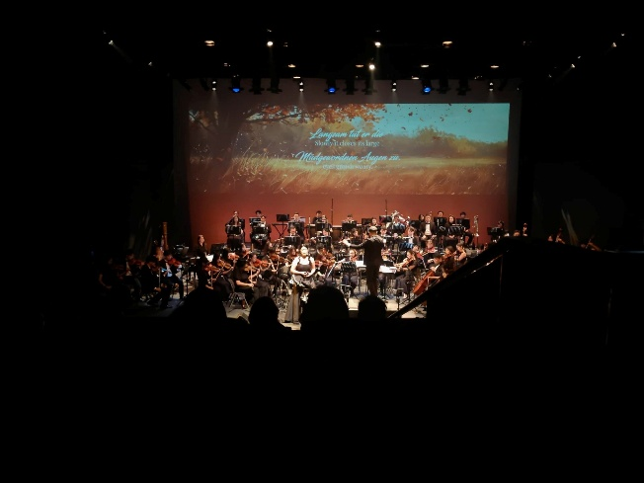 | 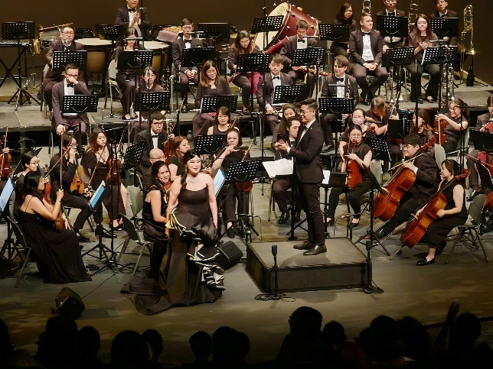

Ang Mei Foong as Mimì in Puccini's "La bohème"
Kuala Lumpur City Opera
Bernard Tan Yong Boon/ Conductor
Kuala Lumpur City Opera Orchestra
4-6 Oct 2024

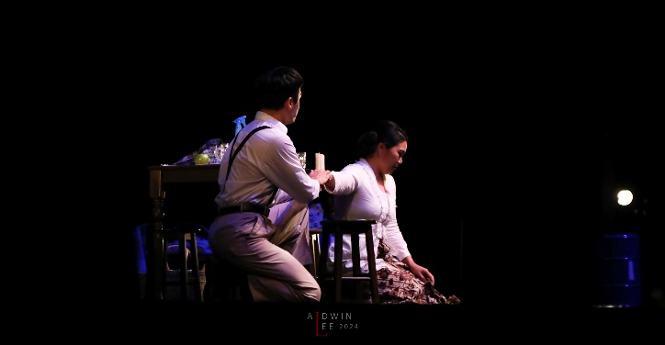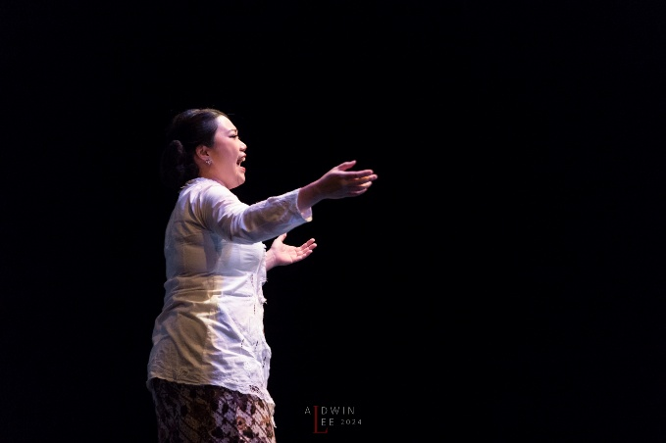 | 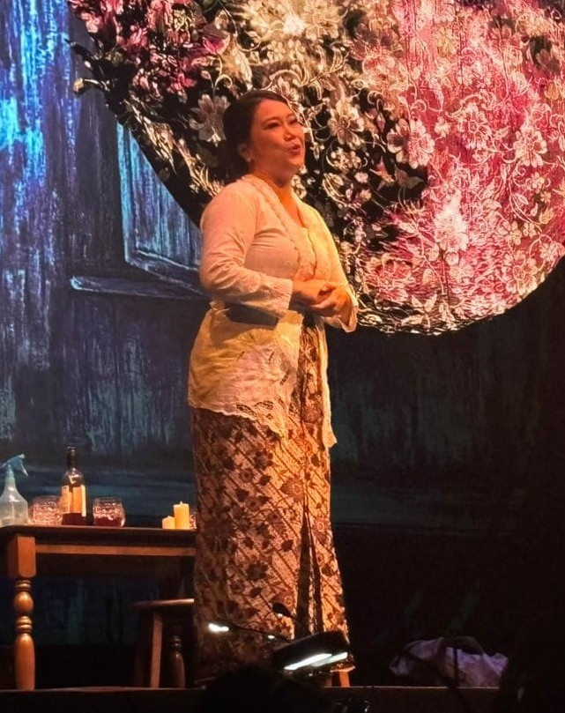

Ang Mei Foong as Violetta Valéry in Verdi's "La Traviata"
Kuala Lumpur City Opera
Juan Montoya/ Conductor
Kuala Lumpur City Opera Orchestra
27, 29 June 2019
Photos courtesy of KL City Opera; Photo credit Eddy Chin from KO Creative Filmmaker Production., and Eddie Tan.

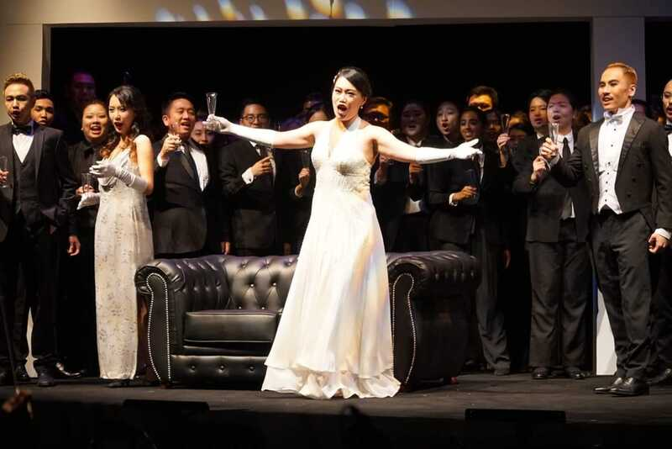 | 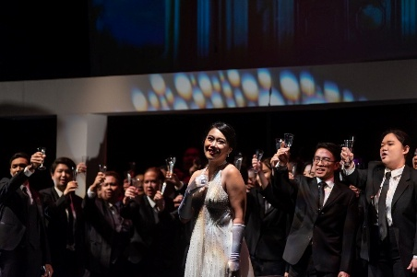 | 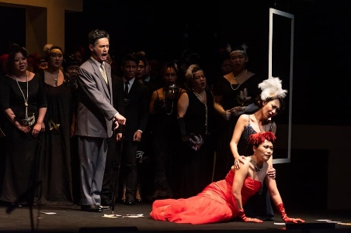
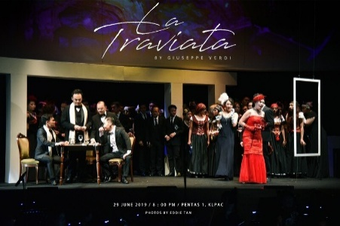 | 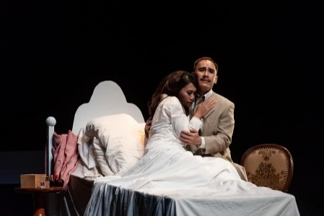 | 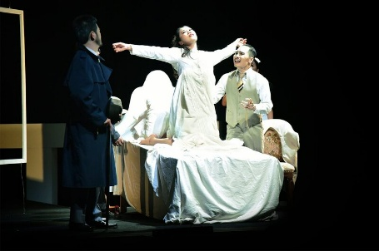

Ang Mei Foong as Contessa in Mozart's "Le Nozze di Figaro"
Kuala Lumpur City Opera
Juan Montoya/ Conductor
Kuala Lumpur City Opera Orchestra
12, 14-15 Oct 2017

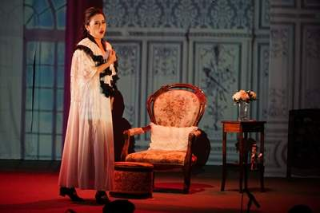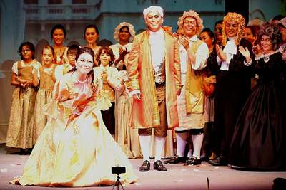 | 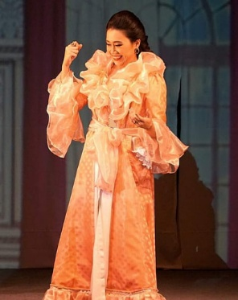

Ang Mei Foong as The First Lady in Mozart's "Magic Flute"
Guillaume Tourniaire/ Conductor,
with the Malaysian Philharmonic Orchestra (MPO)
14, 15, 17 Jan 2017
Dewan Filharmonik Petronas (DFP), KLCC, Kuala Lumpur, Malaysia

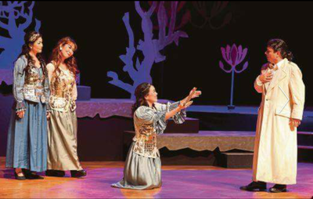 | 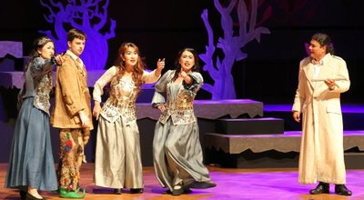

Ang Mei Foong as Mimì in Puccini's "La bohème"
Kuala Lumpur City Opera
Juan Montoya/ Conductor
Kuala Lumpur City Opera Orchestra
25-27 Aug 2016
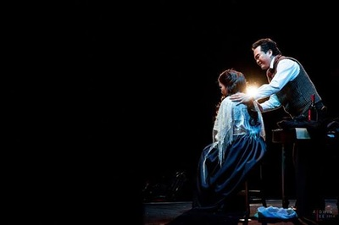  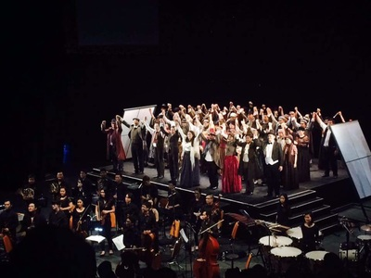 | 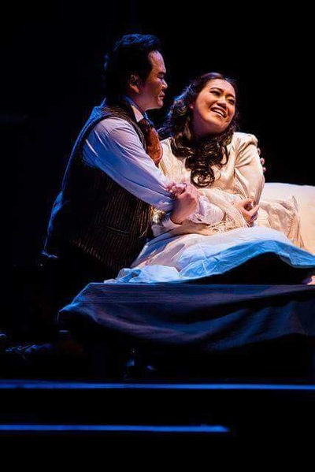

Ang Mei Foong as Soprano Soloist in Handel's Messiah (2016)
​Paul Baker/ Conductor
Grace Convention Center

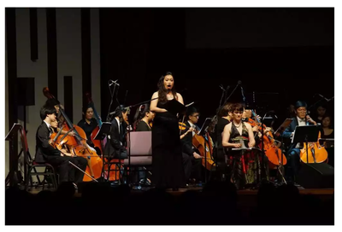 | 